Chapter 14
Exchange Rates and the Foreign Exchange Market:
An Asset Approach

■ Chapter Organization
Exchange Rates and International Transactions.
Domestic and Foreign Prices.
Exchange Rates and Relative Prices.
The Foreign Exchange Market.
The Actors.

Characteristics of the Market.
Spot Rates and Forward Rates.
Foreign Exchange Swaps.
Futures and Options.
The Demand for Foreign Currency Assets.
Assets and Asset Returns.

Risk and Liquidity.
Interest Rates.
Exchange Rates and Asset Returns.
A Simple Rule.
Return, Risk, and Liquidity in the Foreign Exchange Market.
Equilibrium in the Foreign Exchange Market.
Interest Parity: The Basic Equilibrium Condition.
How Changes in the Current Exchange Rate Affect Expected Returns.
The Equilibrium Exchange Rate.
Interest Rates, Expectations, and Equilibrium.
The Effect of Changing Interest Rates on the Current Exchange Rate.
The Effect of Changing Expectations on the Current Exchange Rate.
Case Study: What Explains the Carry Trade?
Forward Exchange Rates and Covered Interest Rate Parity

Summary

■ Chapter Overview
The purpose of this chapter is to show the importance of the exchange rate in translating foreign prices into domestic values as well as to begin the presentation of exchange rate determination. Central to the treatment of exchange rate determination is the insight that exchange rates are determined in the same way as other asset prices. The chapter begins by describing how the relative prices of different countries’ goods are affected by exchange rate changes. This discussion illustrates the central importance of exchange rates for cross-border economic linkages. The determination of the level of the exchange rate is modeled in the context of the exchange rate’s role as the relative price of foreign and domestic currencies, using the uncovered interest parity relationship.
The euro is used often in examples. Some students may not be familiar with the currency or aware of which countries use it; a brief discussion may be warranted. A full treatment of EMU and the theories surrounding currency unification appears in Chapter 21.
The description of the foreign exchange market stresses the involvement of large organizations (commercial banks, corporations, nonbank financial institutions, and central banks) and the highly integrated nature of the market. The nature of the foreign exchange market ensures that arbitrage occurs quickly so that common rates are offered worldwide. A comparison of the trading volume in foreign exchange markets to that in other markets is useful to underscore how quickly price arbitrage occurs and equilibrium is restored. Forward foreign exchange trading, foreign exchange futures contracts, and foreign exchange options play an important part in currency market activity. The use of these financial instruments to eliminate short-run exchange rate risk is described.
The explanation of exchange rate determination in this chapter emphasizes the modern view that exchange rates move to equilibrate asset markets. The foreign exchange demand and supply curves that introduce exchange rate determination in most undergraduate texts are not found here. Instead, there is a discussion of asset pricing and the determination of expected rates of return on assets denominated in different currencies.
Students may already be familiar with the distinction between real and nominal returns. The text demonstrates that nominal returns are sufficient for comparing the attractiveness of different assets. There is a brief description of the role played by risk and liquidity in asset demand, but these considerations are not pursued in this chapter. (The role of risk is taken up again in Chapter 18.)
Substantial space is devoted to the topic of comparing expected returns on assets denominated in domestic and foreign currency. The text identifies two parts of the expected return on a foreign currency asset (measured in domestic currency terms): the interest payment and the change in the value of the foreign currency relative to the domestic currency over the period in which the asset is held. The expected return on a foreign asset is calculated as a function of the current exchange rate for given expected values of the future exchange rate and the foreign interest rate.
The absence of risk and liquidity considerations implies that the expected returns on all assets traded in the foreign exchange market must be equal. It is thus a short step from calculations of expected returns on foreign assets to the uncovered interest parity condition (UIP). The foreign exchange market is shown to be in equilibrium only when UIP holds. Thus, for given interest rates and given expectations about future exchange rates, UIP determines the current equilibrium exchange rate. The interest parity diagram introduced here is instrumental in later chapters in which a more general model is presented. Because a command of this interest parity diagram is an important building block for future work, we recommend drills that employ this diagram.
The result that a dollar appreciation makes foreign currency assets more attractive may appear counterintuitive to students—why does a stronger dollar reduce the expected return on dollar assets? The key to explaining this point is that, under the static expectations and constant interest rates assumptions, a dollar appreciation today implies a greater future dollar depreciation; so, an American investor can expect to gain not only the foreign interest payment but also the extra return due to the dollar’s additional future depreciation. The following diagram illustrates this point. In this diagram, the exchange rate at time t + 1 is expected to be equal to E. If the exchange rate at time t is also E, then expected depreciation is 0. If, however, the exchange rate depreciates at time t to E′, then it must appreciate to reach E at time t + 1. If the exchange rate appreciates today to E″, then it must depreciate to reach E at time t + 1. Thus, under static expectations, a depreciation today implies an expected appreciation and vice versa.

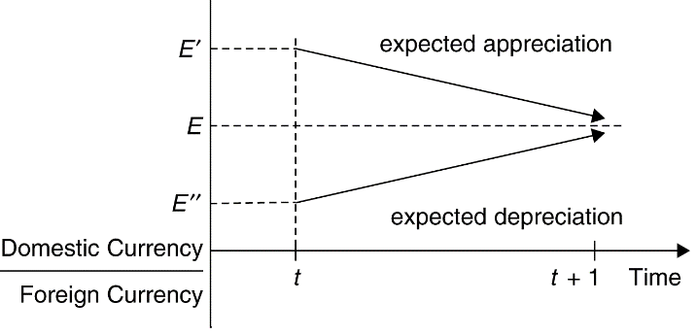

Figure 14-1
This pedagogical tool can be employed to provide some further intuition behind the interest parity relationship. Suppose that the domestic and foreign interest rates are equal. Interest parity then requires that the expected depreciation is equal to zero and that the exchange rate today and next period is equal to E. If the domestic interest rate rises, people will want to hold more domestic currency deposits. The resulting increased demand for domestic currency drives up the price of domestic currency, causing the exchange rate to appreciate. How long will this continue? The answer is that the appreciation of the domestic currency continues until the expected depreciation that is a consequence of the domestic currency’s appreciation today just offsets the interest differential.
The text presents exercises on the effects of changes in interest rates and of changes in expectations of the future exchange rate. These exercises can help develop students’ intuition. For example, the initial result of a rise in U.S. interest rates is a higher demand for dollar-denominated assets and thus an increase in the price of the dollar. This dollar appreciation is large enough that the subsequent expected dollar depreciation just equalizes the expected return on foreign currency assets (measured in dollar terms) and the higher dollar interest rate.
An interesting case study looks at a situation in which interest rate parity may not hold: the carry trade. In a carry trade, investors borrow money in low-interest currencies and buy high-interest-rate currencies, often earning profits over long periods of time. However, this transaction carries an element of risk as the high-interest-rate currency may experience an abrupt crash in value. The case study discusses a popular carry trade in which investors borrowed low-interest-rate Japanese yen to purchase high-interest-rate Australian dollars. Investors earned high returns until 2008, when the Australian dollar abruptly crashed, losing 40% of its value. This was an especially large loss as the crash occurred amidst a financial crisis in which liquidity was highly valued. Thus, when we factor in this additional risk of the carry trade, interest rate parity may still hold.
The chapter concludes with a discussion of covered interest rate parity (CIP), which replaces the expected exchange rate from UIP with the forward exchange rate. When there is a high correlation between the forward exchange rate and the expected exchange rate, the CIP and UIP conditions are very similar. However, CIP failed to hold during the Global Financial Crisis of 2007-2008 when there was increased uncertainty about the ability of banks to cover forward exchange rate contracts. Even after the financial crisis, CIP has failed to hold suggesting a profitable arbitrage opportunity for currency investors. This is an interesting puzzle given that fears of bank default are likely not the main explanation for the sustained failure of CIP over this period.

■ Answers to Textbook Problems
1. At an exchange rate of 1.05 $ per euro, a 5 euro bratwurst costs 1.05$/euro × 5 euros = $5.25. Thus, the bratwurst in Munich is $1.25 more expensive than the hot dog in Boston. The relative price is $5.25/$4 = 1.31. A bratwurst costs 1.31 hot dogs. If the dollar depreciates to 1.25$/euro, the bratwurst now costs 1.25$/euro × 5 euros = $6.25, for a relative price of $6.25/$4 = 1.56. You have to give up 1.56 hot dogs to buy a bratwurst. Hot dogs have become relatively cheaper than bratwurst after the depreciation of the dollar.
2. If it were cheaper to buy Israeli shekels with Swiss francs that were purchased with dollars than to directly buy shekels with dollars, then people would act upon this arbitrage opportunity. The demand for Swiss francs from people who hold dollars would rise, causing the Swiss franc to rise in value against the dollar. The Swiss franc would appreciate against the dollar until the price of a shekel would be exactly the same whether it was purchased directly with dollars or indirectly through Swiss francs.

Take for example the exchange rate between the Argentine peso, the US dollar, the euro, and the British pound. One dollar is worth 68.8026 pesos, while a euro is worth 77.1927 pesos. To rule out triangular arbitrage, we need to see how many pesos you would get if you first bought euros with your dollars (at an exchange rate of 0.8913 euros per dollar), then used these euros to buy pesos. In other words, we need to compute E_{ARG/USD} = E_{EUR/USD} × E_{ARG/EUR} = 0.8913*77.1927=68.8019. This is almost exactly (with rounding) equal to the direct rate of pesos per dollar. A similar procedure for the British pound shows that E_{ARG/USD} = E_{GBP/USD} × E_{ARG/GBP} = 0.7939*86.6673=68.8052. Again, this is almost exactly equal to the direct rate of pesos per dollar.
We need to say that triangular arbitrage is “approximately” ruled out for several reasons. First, rounding error means that there may be some small discrepancies between the direct and indirect exchange rates we calculate. Second, transactions costs on trading currencies will prevent complete arbitrage from occurring. That said, the massive volume of currencies traded make these transactions costs relatively small, leading to “near” perfect arbitrage.
3. The table below gives the exchange rates for the Argentine Peso, Chinese Yuan, Japanese Yen, Mexican Peso, and South African Rand against the US dollar, Euro, and British Pound. The fifth column shows the exchange rate determined as the exchange rate in terms of the currency per euro multiplied by the euros per dollar exchange rate (0.8913). The sixth column does the same calculation, but uses British pounds instead of euros (using 0.7939 pounds per dollar).
 | E_{C/USD} | E_{C/EUR} | E_{C/GBP} | E_{C/EUR}*E_{EUR/USD} | E_{C/GBP}*E_{GBP/USD}
Argentina | 68.8026 | 77.1927 | 86.6673 | 68.8019 | 68.8052
China | 7.1099 | 7.9769 | 8.9560 | 7.1098 | 7.1102
Japan | 108.825 | 122.0956 | 137.0816 | 108.8238 | 108.8291
Mexico | 21.595 | 24.2284 | 27.2022 | 21.5948 | 21.5958
South Africa | 16.9163 | 18.9791 | 21.3086 | 16.9161 | 16.9169

Comparing the second column to the fifth and six columns, we see that they are nearly identical. The small difference between these exchange rates is a result of small transaction costs involved in converting currencies that prevent these very minute price differences from being arbitraged.

4. When the yen depreciates versus the dollar, costs to a Japanese firm that imports petroleum will rise. This depresses its profits. On the other hand, that firm will be able to export more to the United States (increasing its yen price without changing the dollar price), so there may be some offsetting effects. But, by and large, a firm that has substantial imported input costs does not relish a depreciating home currency.

5. The dollar rates of return are as follows:
a. ($250,000 − $200,000)/$200,000 = 0.25.
b. ($275 − $255)/$255 = 0.08.
c. There are two parts to this return. One is the loss involved due to the appreciation of the dollar; the dollar appreciation is ($1.38 − $1.50)/$1.50 = −0.08. The other part of the return is the interest paid by the London bank on the deposit, 10%. (The size of the deposit is immaterial to the calculation of the rate of return.) In terms of dollars, the realized return on the London deposit is thus 2% per year.
6. Note here that the ordering of the returns of the three assets is the same whether we calculate real or nominal returns.
a. The real return on the painting would be 25% − 10% = 15%. This return could also be calculated by first finding the portion of the $50,000 nominal increase in the house’s price due to inflation ($20,000), then finding the portion of the nominal increase due to real appreciation ($30,000), and finally finding the appropriate real rate of return ($30,000/$200,000 = 0.15).
b. Again, subtracting the inflation rate from the nominal return, we get 8% − 10% = −2%.
c. 2% − 10% = −8%.
7. The current equilibrium exchange rate must equal its expected future level since, with equality of nominal interest rates, there can be no expected increase or decrease in the dollar/lb exchange rate in equilibrium. If the expected exchange rate remains at $1.52 per pound and the pound interest rate rises to 10% (5% higher than U.S. interest rates), then interest parity is satisfied only if the current exchange rate changes such that there is an expected appreciation of the dollar equal to 5%. This will occur when the exchange rate rises to $1.60 per pound (a depreciation of the dollar against the pound).
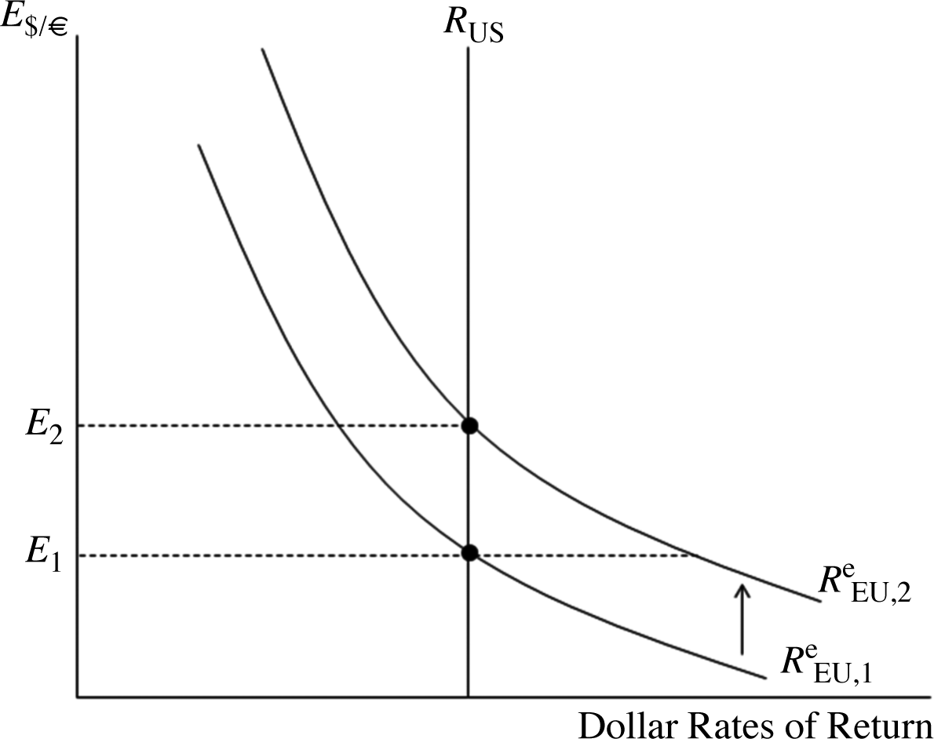
8. If market traders learn that the dollar interest rate will soon fall, they also revise upward their expectation of the dollar’s future depreciation in the foreign exchange market. Given the current exchange rate and interest rates, there is thus a rise in the expected dollar return on euro deposits from to . At the current exchange rate of E₁, the dollar return on a European asset exceeds the dollar return on a U.S. asset. As investors shift their money into European assets, the dollar will depreciate against the euro. This will drive down the dollar return on European assets until interest rate parity is restored at the new exchange rate E₂.

9. The analysis will be parallel to that in the text. As shown in the accompanying diagrams, a movement down the vertical axis in the new graph, however, is interpreted as a euro appreciation and dollar depreciation rather than the reverse. Also, the horizontal axis now measures the euro interest rate.

The two diagrams below show the effects of an increase in European interest rates and an increase in the expected future exchange rate in terms of euros per dollar. In the first case, an increase in European interest rates raises the euro return on a European asset above the euro return on an American asset. This will cause the exchange rate to fall (euro appreciation, dollar depreciation) from E1 to E2.

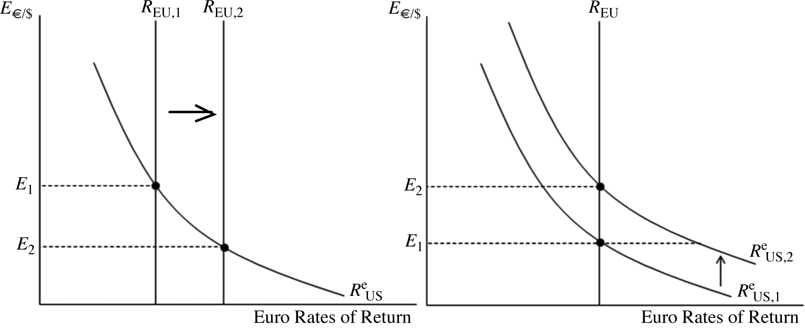
In the second case, the expected appreciation of the dollar raises the euro return on an American asset from to At the current exchange rate, American assets pay a higher euro return and the exchange rate must rise (euro depreciation, dollar appreciation) to restore interest rate parity.
10. a. If the Federal Reserve pushed interest rates down, with an unchanged expected future exchange rate, the dollar would depreciate (note that the article uses the term “downward pressure” to mean pressure for the dollar to depreciate). If there is a “soft landing,” and the Federal Reserve does not lower interest rates, then this dollar depreciation will not occur.
b. The “disruptive” effects of a recession make dollar holdings more risky. Risky assets must offer some extra compensation such that people willingly hold them as opposed to other, less risky assets. This extra compensation may be in the form of a bigger expected appreciation of the currency in which the asset is held. Given the expected future value of the exchange rate, a bigger expected appreciation is obtained by a more depreciated exchange rate today. Thus, a recession that is disruptive and makes dollar assets more risky will cause a depreciation of the dollar.
11. The euro is less risky for you. When the rest of your wealth falls, the euro tends to appreciate, cushioning your losses by giving you a relatively high payoff in terms of dollars. Losses on your euro assets, on the other hand, tend to occur when they are least painful, that is, when the rest of your wealth is unexpectedly high. Holding the euro, therefore, reduces the variability of your total wealth.
12. The chapter states that most foreign exchange transactions between banks (which accounts for the vast majority of foreign exchange transactions) involve exchanges of foreign currencies for U.S. dollars, even when the ultimate transaction involves the sale of one nondollar currency for another nondollar currency. This central role of the dollar makes it a vehicle currency in international transactions. The reason the dollar serves as a vehicle currency is that it is the most liquid of currencies because it is easy to find people willing to trade foreign currencies for dollars. The greater liquidity of the dollar as compared to, say, the Mexican peso, means that people are more willing to hold the dollar than the peso, and thus, dollar deposits can offer a lower interest rate, for any expected rate of depreciation against a third currency, than peso deposits for the same rate of depreciation against that third currency. As the world capital market becomes increasingly integrated, the liquidity advantages of holding dollar deposits as opposed to euro deposits will probably diminish. The euro represents an economy as large as the United States, so it is possible that it will assume some of that vehicle role of the dollar, reducing the liquidity advantages to as far as zero. When it was first introduced in 1999, the euro had no history as a currency, though, so some investors may have been leery of holding it until it established a track record. As the euro has become more established, though, the liquidity advantage of the dollar should be fading (albeit slowly).
13. The interest rate parity condition tells us that interest rates and exchange rates are directly linked. As interest rates become more volatile, so too will exchange rates. For example, suppose that the European Central Bank actively limits fluctuations in euro interest rates while the Federal Reserve does not intervene to keep dollar interest rates stable. Interest rate parity states that:
If the left-hand side of this equation becomes more volatile, then so too must the right-hand side. Assuming that expectations remain unchanged, then this increase in volatility will be reflected in higher variablility of the exchange rate.
14. A tax on interest earnings and capital gains leaves the interest parity condition the same because all its components are multiplied by one less the tax rate to obtain after-tax returns. If capital gains are untaxed, the expected depreciation term in the interest parity condition must be divided by 1 less the tax rate. The component of the foreign return due to capital gains is now valued more highly than interest payments because it is untaxed.
15. The forward premium can be calculated as described in the Appendix. In this case, we find the forward premium on euro to be (1.26 − 1.20)/1.20 = 0.05. The interest rate difference between
one-year dollar deposits and one-year euro deposits will be 5% because the interest difference must equal the forward premium on euro against dollars when covered interest parity holds.
16. The value should have gone down as there is no more need to engage in intra-EU foreign currency trading. This represents the predicted transaction cost savings stemming from the euro. At the same time, the importance of the euro as an international currency may have generated more trading in euros as more investors (from central banks to individual investors) choose to hold their funds in euros or denominate transactions in euros. On net, though, we would expect the value of foreign exchange trading in euros to be less than the sum of the previous currencies.
17. If the dollar depreciated, all else being equal, we would expect outsourcing to diminish. If, as the problem states, much of the outsourcing is an attempt to move production to locations that are relatively cheaper, then the United States becomes relatively cheap when the dollar depreciates. Although it may not be as cheap a destination as some other locations, at the margin, labor costs in the United States will have become relatively cheaper, making some firms choose to retain production at home. For example, we could say that the labor costs of producing a computer in Malaysia is $220 and the extra transport cost is $50, but the U.S. costs were $300; then we would expect the firm to outsource. On the other hand, if the dollar depreciated 20% against the Malaysian ringitt, the labor costs in Malaysia would now be $264 (that is, 20% higher in dollar terms, but unchanged in local currency). This, plus the transport costs, makes production in Malaysia more expensive than in the United States, making outsourcing a less attractive option.
18. They key here is to compute the return on the carry trade by accounting for not only the difference between Korean and American interest rates, but also the percentage change in the value of the Korean won against the dollar. The risk of the carry trade is that the won might depreciate against the dollar, thus negating the higher interest rate paid on Korean bonds. Using data from January 2009 through December 2019, a carry trade described in this problem would have the following cumulative return:

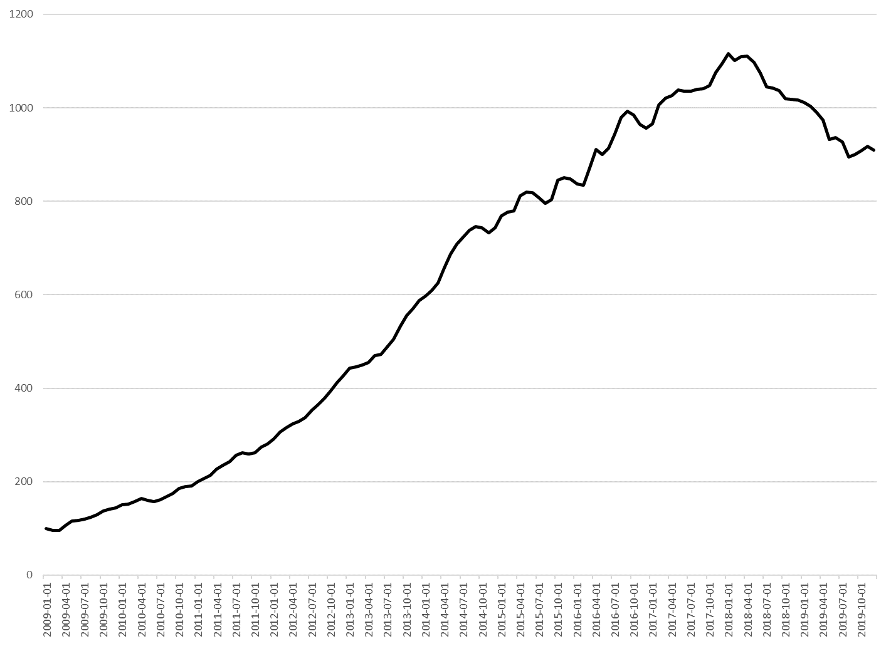
Though there are periods in which the cumulative return declines (almost always due to a depreciation of the Korean won against the U.S. dollar), the general trend is upward suggesting a significant arbitrage opportunity from borrowing U.S. dollars to invest in Korean bonds.

  - As per the question, a currency depreciation benefits exporters and hurts consumers by raising the cost of living. Exporters tend to have more influence with the government for two reasons. First, there are fewer exporters than there are consumers, so the gains from a currency depreciation are much more heavily concentrated than the losses. As a result, each individual exporter will put forth more effort in lobbying the government than each individual consumer. Second, exporters are much easier to organize and coordinate than are a disparate mass of consumers. There are effective enforcement mechanisms in place to ensure that all exporters contribute to get a government to depreciate the currency, thus reducing the risk of free riding. Consumers will have a much harder time coordinating their lobbying efforts because there is no effective way to ensure that every consumer contributes toward such an effort. The risk of free riding is much higher among consumers.

